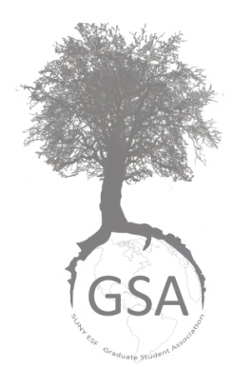
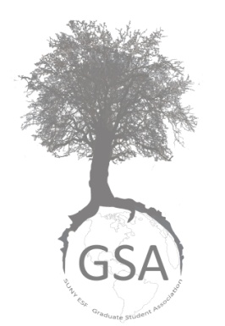
State University of New York
College of Environmental Science and Forestry

Graduate Student Association

Travel Grant Guidelines

Contact Information

Contacts | Email / Mail
Chair of Grants and Awards:  Jorge Garcia Polo | gsa.esf@gmail.com  GSA Mailbox  (located in the basement of Marshall Hall, to the right of the Gallery Snack Bar)

Purpose
The purpose of the Travel Grant is to provide support for graduate student travel incurred while presenting original work or for professional development.

The Travel Grant is intended to enhance graduate student education through participation in conferences and seminars. The grant is designed to cover costs associated with such travel.

Due Dates
Due dates for the academic year 2017-2018:

Semester |  | Due Date
Fall 2017  Spring 2018 |  | November 17th, 2017  April 13th, 2018

Fall submissions are for travel between October 1, 2017 – March 31, 2018. Spring submissions are for travel between April 1, 2018 – September 30, 2018.

Submission Method
All forms must be submitted electronically to gsa.esf@gmail.com. PDF files are required to avoid incompatibility between PC / Mac platforms. Documents should be submitted as one PDF file, with the signed Application Form scanned.

What does this grant fund?
The Travel Grant can be used to cover travel-related expenses when presenting scholarly research at local, national, or international conferences and scientific meetings. These awards are specifically for graduate students presenting their original research either as a poster or oral presentation. The grant can also be used to fund graduate students attending professional development seminars and workshops where they will be presenting their research. Seminars and workshops must be standalone events (as opposed to affiliated with a conference) to be eligible for funding. If your travel does not clearly fit into one of these categories, please contact the chair of the grant committee.

Grant money can be used to fund mileage, airfare, rental cars, and accommodations. Current mileage rates can be found at the ESF Office of Business Affairs (http://www.esf.edu/business/travel.htm).

This grant cannot be used to cover food, conference registration, parking, or other supplementary expenses. It cannot be used to fund travel conducted prior to October 1st (Fall applicants) or April 1st (Spring applicants) or to fund travel to conduct research. Expenses incurred as part of research may be fundable through GSA Research grants. The grant committee may reject any application if the travel is not for the presentation of results or career building activities. Please contact the Grant Committee Chair if you have any concerns over whether or not your travel expenses are eligible.

Availability of funds
Each recipient will receive a maximum of $250.00 based on their submitted budget. Awards may be adjusted based on submitted budgets, number of applicants, and availability of funds. The grant committee will try to fund as many applications as possible, depending on the availability of funds.

Eligibility
Any SUNY ESF graduate student that is enrolled for at least 1 credit hour and progressing toward a graduate level degree can apply. No preference is given based on student degree program or seniority. Students who graduate prior to the end of the travel period are eligible to apply. Travel must take place after the application deadline for the semester but must be completed before the end of the travel period. Only one Travel Grant may be received each academic year. Funding may only be requested for one conference or seminar. *Masters students can receive up to 2 travel grants and PhD students can receive up to 3 travel grants during their time at ESF.

Awarding the grants
GSA Travel Grants are awarded by merit, need, and diversity of research topics. Each semester, all completed applications received by the deadline will be entered into a lottery. The GSA Grant Committee does not evaluate conferences or seminars for merit. Each applicant has an equal chance to be a recipient of a Travel Grant. Winners will be chosen until funding is exhausted. If there is funding remaining, more applications will be drawn and awarded based on the remaining amount.

Application requirements
A Travel Grant application MUST include these components in order to be eligible for funding:

1. Application Form: The applicant must download the Travel Grant application form from the GSA call for applications email or GSA webpage and complete all of the fields.
- All responses must be typed in the downloaded document using the autocomplete form (except for the signatures).
- The signatures of the applicant and the applicant’s academic advisor must be handwritten. Both signatures are required for the form to be considered complete.

2. Budget: The applicant must provide a single page, tabular budget for the entire trip. The budget should list all the expenses and the applicant should indicate which items would be funded by the grant. GSA Travel Grants can be requested to fund items that are directly related to travel expenses. Examples include airfare, ground transportation, hotel accommodation, and gas. GSA Travel Grants cannot be used food/drink expenses, field trips, or registration fees.

The budget should be detailed and provide the sources for the price quotes. Any funding from other sources should be noted in the budget with a list of items that will be covered by these funds. Example sources of other funding sources include: advisor’s funds, department/college funds, and other grants/awards.

Budgets must closely follow the format and layout of the Example Budget available on the GSA Travel Grants web page. Budget compliance and clarity is a key component for submission acceptance.

3. Documentation of Acceptance: The applicant must provide documentation of acceptance to present at the specified conference or attend the specified seminar / workshop. Examples of official documentation include a letter /email of acceptance of a presentation, a similar document for registration for a seminar or workshop, or a copy of the conference program listing the presentation.

If official acceptance has not yet been received by the deadline for Travel Grant applications, the applicant can still submit the grant application. However, funding will not be dispensed until documentation is provided.

Notifications
Once the review session has been conducted, Travel Grant applicants will be notified whether or not they have won the award via email.

Getting the money
GSA Travel Grants are provided as soon as possible following notification of the award. Recipients should conduct their travel and submit receipts representing the total cost of travel to the GSA Grant Committee Chair for proof of travel. Mileage can be reported by submitting a copy of the conference or meeting agenda and a State Travel Expense Worksheet found at the ESF Office of Business Affairs (http://www.esf.edu/business/travel.htm).

Recipients should submit their proof of travel document as soon as possible after travel is completed.

Proof of travel along with the final report (see details below) needs to be submitted both in paper to the GSA mailbox and electronically to gsa.esf@gmail.com.

Final Report
Each recipient must submit a final report with their proof of travel documents. The report should include:

- A brief report detailing the conference, seminar, or workshop and how this experience benefited the recipient professionally. (1 page maximum)
- A complete budget for the actual cost of travel. This should include how the Travel Grant was spent, how any additional sources of funding were spent, and any out of pocket expenses. An official form will be provided (An official form will be provided).

Failure to provide proof of travel expenditure documentation and the final report can result in (but is not limited to) a ban from all future GSA grants and awards and a formal notification to your advisor and department chair.

Please allow 4-6 weeks after submitting your final report and receipts to receive a reimbursement check. The check will be available in the Bursar’s Office.

