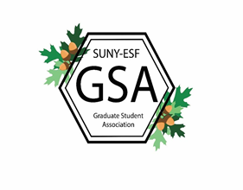

SUNY College of Environmental Science and Forestry (SUNY-ESF)
Graduate Student Association (GSA) Senate
Travel Grant Application 2018-2019

- Submission
Semester of Application_____________________
Year_______________

- Applicant
Name ____________________________________
ID Number_____________________
Graduating Class________________
Degree________________________ Department _____________________
Email_________________________ Phone/cell______________________
Advisor________________________ Advisor’s Email_________________
- Travel information
Conference Name _______________________________________________________
Location _____________________
Start Date _____________________ End Date _____________________
I have been accepted as a conference presenter at this time. Yes/No
If no, provide reason____________________________________________________

- Justification
Provide a brief overview of the nature of your research and the conference (250 words or less).

- Signatures
By signing this document, I agree to all the terms and conditions of the Graduate Student Association Travel Grant Program as outlined in the travel grant guidelines.

_________________________________________________ __________
Student Signature Date

________________________________________________ __________
Advisor’s Signature Date

