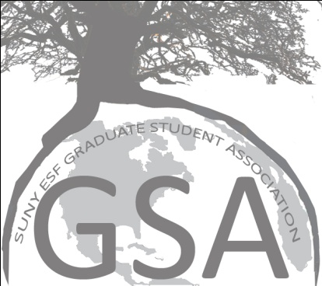

Reminders/Follow-up:
DInesh: needs volunteers (including Katie D’Amico) to review travel grants
Katie B (or someone): double-check who has Board of Trustees Vote
Katie B: Graduate Student Rights and Responsibilities meeting with Scott Shannon
Bali: Life Coach name/info to Whitney for Grants Workshop
Bali and Lewis: discuss Standing on the Shoulders of Giants speaker
Agenda:

- RIN and Travel Grants
  - 8 applications so far
  - Need selection committee, decision to applicants by 15th, hour long meeting Nov. 10th afternoon sometime
    - Katie D’Amico, someone else volunteer
    - Confirm budget for these awards/grants
- Unite Way updates
  - Future follow-up scheduled with Terry
  - USA voted to support fundraiser, unknown what our involvement will be
- GSA events
  - Trash free – can we?
    - TGs might be doing alright
    - International Panel: provided for the forgetful
    - Michael D: no reason not to, draw a hard line, food gets eaten somehow anyways
      - provide eating accessories to important people
    - ALL CHAIRS must include “trash-free” in promotional items
    - Consider this in food choices (no rice, yes pizza)
    - Decrease Waste as a goal of the organization
  - T-shirts
    - Wear at events!
    - $15.00 each if people want to purchase them
  - Photos
    - Take pictures for website
    - As item in Event Plans
    - Official camera for GSA? Use a previous gift card
    - Yearbook wants a GSA photo, due by end of exams in Spring
  - Post-game
    - Cleaning up after events (from Nifkin to dishes, take care of extra foods)
    - At least by the next day, if not immediately afterwards
- Board of Trustees (Shiuli)
  - Meeting was Oct. 22nd
  - Review of meeting provided by Shiuli, contact her for additional details
- Weekly follow ups
  - Lewis synching calendars (working on with Katie D)
    - Share calendar from google account with campus, integrate events with personal calendars; maybe Outlook can sync as well
    - See if google calendar can be imbedded on the Website
  - Graduate rights and responsibilities
    - Set up meeting directly with Scott Shannon to discuss (Katie B)
  - Bali send information about Life Coach to Whitney for Grant Workshop
- Committee updates
  - International (Bali)
    - Getting foam boards back from PP (or from campus buildings)
    - Ideas raised at recent panel
      - Host specific event for International students (and others) to describe their experiences here, open forum in spring or next fall
      - Work more in the future with Raydora
        - Ambassadors to new students at airport, through first week of classes
        - Mentors from old to new students
    - Panel on Climate Change postponed until April
      - Potential for Standing on the Shoulders of Giants
        - Bali and Lewis discuss
  - Professional Development
    - Professional Conferences Nov. 2nd
    - Writing Research Proposal Dec. 2nd
  - Speaker Committee
    - Friday Nov. 19th Michael Dimpfl 12 pm in Moon Library
  - All GSA members should participate in events outside their own committees
- Departmental updates
  - Need to address equality of participation for the Spotlight on Research by department; How much was contributed by each department last year (EFB)?

Attendance:

Katie Barnhill
Lewis Grove
Dineshkumar Moghariya
Abbie Larkin
Katie D-Amico
Whitney Lash Marshall
Braulio Quintero
Shiuli Mahmud
Laura Calendra
Neal Maker
Yazmin Rivera
Artem Treyger
Marvin Montefrio
Michael Dimpfl
Doug Morrison

**Thanks for the help keeping up with the minutes Lewis and Katie D

