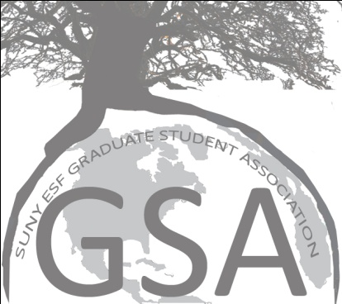

Reminders/Follow-up:
Katie Barnhill: please email listserv to see if anyone lost an orange Syracuse sweatshirt at the last TG
Michael A: confirm TG, create list of tasks to be assigned
Bali: check into last year’s folder for guidelines on student’s rights panel
Shiuli: get Board of Trustees agenda to GSA members before the meeting for comments
Sara: publicize law school Halloween bash? Are we invited? Confirm please.
Katie B: Please put Jason Hamidi on next meeting’s agenda for communication seminar idea
Michale A: what is the status of the refrigerator?

ALL COMMITTEE CHAIRS/NON-DEPARTMENT REPS SHOULD GATHER INFORMATION FOR THEIR PAGE ON THE WEBSITE AND GET IT TO KATIE D’AMICO BEFORE NEXT MEETING!

Executive Meeting
- TG rescheduled
  - Move to Oct. 22
    - Assign tasks to specific individuals
  - Make alternative to Beer/Wine: lemonade or iced tea
  - More members on Social Committee!
  - Joint TG w. international committee around a foreign holiday
  - Adjust time of TG (a bit later)
- International
  - Ryan Mann (anthropology PhD student at CUNY) Nov. 3rd
    - Climate Change conference in Bolivia
      - How to bring Climate Change problem to the local level
    - Different perspective than biologists/ecologists
    - Budget to cover bus ticket = $88.00
  - Panel on International Students
    - Oct. 20th check into guidelines from last year
Agenda:

- Safety Committee (Imran)
  - Did not show
- SUNY Student Assembly Oct 29-31
  - Did not discuss
- Joe Rufo Meeting (Whitney)
  - Computer lab = work in progress
    - Issue of security, Physical Plant and University Police
  - Swipe card: reprogram, send in list
  - Grant workshop: meeting with Neal Ringler, others from Research office
  - Procurement Cards in the works
  - Business Cards: will email Joe Rufo (Abbie)
- Event Debriefings
  - TG (Michael)
    - Next TG moved to 22nd
      - Halloween themed
      - Split from undergrads
        - Concerns of: crowding, party w/ students, costuming
      - Check for start time based on end time (when we lose the space)
      - Confirm reservation right away! (For October and November)
    - Dec. 3 TGIF (Thanksgiving theme), Dec. 10 TGIO
  - Movie (Bali)
    - Sita Sings the Blues, discussion afterwards
    - Low turnout, will repeat with more organization and maybe refreshments
    - Put on again in the spring, on the quad
- Survey Results (Whitney)
  - Should ask next time if respondents are masters or PhD students
  - Most know of the website, continue to link on fliers
  - Prof Dev workshops: manuscript writing, careers, research proposal, professional conferences
    - Shiuli pushes for Preparing for Candidacy Exams workshop, although there is concern that this topic might not be general enough
  - Continue trash free events
  - International night: people like homemade foods, include American food
  - Speaker nominations: long list for committee to sort through
    - Research committee wanted to put on student presentations as well
- Departmental Updates (Dept. Reps)
  - Board of Trustees Meeting Oct. 22nd
    - Pass agenda around GSA so we can comment (Shiuli)
  - Laura ERE meeting with chair and coordinator
  - Sara: GSO and Law School Halloween bash Oct. 30
    - Whether to publicize or not, not certain we are invited
      - Next time: how to solidify our relationship with them.
    - Make website page of benefits, link to GSO
  - SU grads helping with Habitat for Humanity, came to TG, enjoyed
- Website needs to be maintained (esfgsa.webs.com)
  - Chairs need to send all information for their pages to Katie, she will put on the site by next meeting
  - Anyone can put events on the ESF calendar through the portal
    - Katie Barnhill – put events on the Calendar
  - Email constitution to Katie D for website attachment
- International Education week at SU (Bali)
  - Free music festival mid November (11-15ish)
  - GSA can promote: Katie B emails community, send flier to Katie D for website
  - Auditions in October
- Newhouse graduate student: wants to do communication seminar at ESF
  - Doesn’t need monetary support, come to next meeting, put on agenda.
  - Jason Hamidi
- Upcoming event
  - David Murphy 110 moon 12 pm Oct. 15th, light refreshments.
- Banner and Podium sign, take care of them please.

