Graduate Student Association
Meeting Agenda
21 September 2010

SU’s GSO (Paul Preczewski)

Graduate Student Advisory Council (Katie B)

Forum on Teaching & Learning (Katie B)

Committee Updates & Work Plans (all committee chairs)
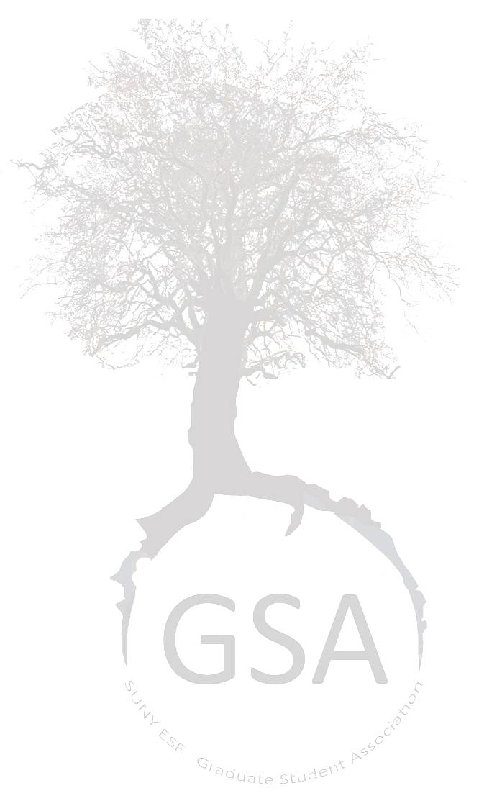
Survey (Whitney)

GSA Purchasing + Furniture Moving (Katie B)

Budget 2010-2011 (Dinesh)

Departmental Updates (all reps)

Meeting with Joe Rufo, VP of Administrative Affairs (Katie B)

Announcements & Reminders

